**MUHAMMAD HAMAD**

**ASSIGNMENT 2: CHAPTER 7: ACCOUNTING**

Early decision support solutions focused on the analysis of financial data. Financial analysts are some of the most data-literate and spreadsheet-savvy individuals. The DW system can provide a single source of usable, understandable financial information, ensuring everyone is working oﬀ the same data with common  
definitions and common tools.

The **audience for financial data is quite diverse** in many organizations, ranging from analysts to operational managers to executives. For each group, you need to determine which subset of corporate financial data is needed, in which format, and with what frequency. **Analysts and managers** want to view information at a high level and then drill to the journal entries for more detail. **For executives**, financial data from the DW/BI system often feeds their dashboard scorecard of key performance indicators. Armed with direct access to information, **managers** can obtain answers to questions more readily than when forced to work through a middleman. Meanwhile, **finance** can turn their attention to information  
dissemination and value-added analysis, rather than focusing on report creation

Improved access to accounting data allows you to focus on opportunities to better manage risk, streamline operations, and identify potential cost savings.

General Ledger Data

The *general ledger* (*G/L*) is a core foundation financial system that ties together the detailed information collected by sub ledgers or separate systems for purchasing, payables (what you owe to others), and receivables (what others owe you).

Chart of Accounts

The cornerstone of the general ledger is the chart of accounts. The chart of accounts is a listing of all accounts used in the general ledger of an organization. The chart is used by the accounting software to aggregate information into an entity's financial statements. The chart is usually sorted in order by account number, to ease the task of locating specific accounts.

If you are tasked with building a comprehensive general ledger spanning multiple organizations in the DW/BI system, you should try to conform the chart of accounts so the account types mean the same thing across organizations. At the data level, this means the master conformed account dimension contains carefully defined account names.

Period Close

At the end of each accounting period, the finance organization is responsible for finalizing the financial results so that they can be officially reported internally and externally. However, in many organizations, general ledger trial balances are loaded into the DW/BI system leveraging the capabilities of the DW/BI presentation area to find the needles in the general ledger haystack, and then making the appropriate operational adjustments before the period ends

Although the balance doesn’t represent G/L activity, we include the fact in the design because it is so useful. Otherwise, you would need to go back to the beginning of time to calculate an accurate end-of-period balance.

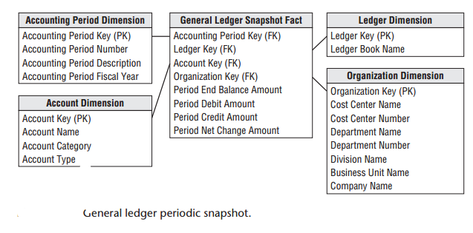

Year-to-Date Facts

Designers are often tempted to store “to-date” columns in fact tables. They think it would be helpful to store quarter-to-date or year-to-date additive totals on each fact row so they don’t need to calculate them. When fact rows are queried and summarized in arbitrary ways, these untrue-to-the-grain facts produce nonsensical, overstated results. They should be left out of the relational schema design and calculated in the BI reporting application instead

Multiple Currencies Revisited

With financial data, you typically want to represent the facts both in terms of the local currency, as well as a standardized corporate currency. In this case, each fact table row would represent one set of fact amounts expressed in local currency and a separate set of fact amounts on the same row expressed in the equivalent  
corporate currency. Doing so allows you to easily summarize the facts in a common corporate currency without jumping through hoops in the BI applications.

General Ledger Journal Transactions

Many users need to dive into the underlying details. If an anomaly is identified at the summary level, analysts want to look at the detailed transactions to sort through the issue. Others need access to the details because the summarized monthly balances may obscure large disparities at the granular transaction level. Again, you can complement the periodic snapshot with a detailed journal entry transaction  
schema. Of course, the accounts payable and receivable subledgers may contain transactions at progressively lower levels of detail, which would be captured in separate fact tables with additional dimensionality

The grain of the fact table is now one row for every general ledger journal entry transaction. The journal entry transaction identifies the G/L account and the applicable debit or credit amount. Each row in the journal entry fact table is identified as either a credit or a debit.

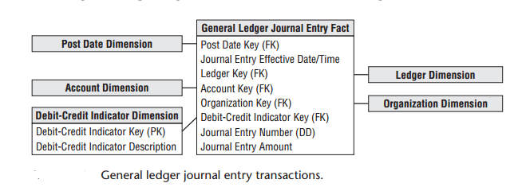

Multiple Fiscal Accounting Calendars

Now the data is captured by posting date, but users may also want to summarize the data by fiscal account period. Unfortunately, fiscal accounting periods often do not align with standard Gregorian calendar months. For example, a company may have 13 4-week accounting periods in a fiscal year that begins on September 1 rather than 12 monthly periods beginning on January 1. If you deal with a single fiscal calendar, then each day in a year corresponds to a single calendar month, as well as a single accounting period. Given these relationships, the calendar and accounting periods are merely hierarchical attributes on the daily date dimension. The daily date dimension table would simultaneously conform to a calendar  
month dimension table, as well as to a fiscal accounting period dimension table

In other situations, you may deal with multiple fiscal accounting calendars that vary by subsidiary or line of business. A given row in the daily date dimension would be identified as belonging to accounting period 1 for subsidiary A but accounting period 7 for subsidiary B.

The most common approach is to create a date dimension outrigger with a multipart key consisting of the date and subsidiary keys. There would be one row in this table for each day for each subsidiary. The attributes in this outrigger would consist of fiscal groupings (such as fiscal week end date and fiscal period end date).

A second approach for tackling the subsidiary-specific calendars would be to create separate physical date dimensions for each subsidiary calendar, using a common set of surrogate date keys.

Drilling Down Through a Multilevel Hierarchy

Large enterprises may have multiple ledgers arranged in an ascending hierarchy, perhaps by enterprise, division, and department. At the lowest level, department ledger entries may be consolidated to roll up to a single division ledger entry. Then the division ledger entries may be consolidated to the  
enterprise level. **One way to model** this hierarchy is by introducing the parent snapshot’s fact table surrogate key in the fact table. In this case, because you define a parent/child relationship between rows, you add an explicit fact table surrogate key, a single column numeric identifier incremented as you add  
rows to the fact table. Suppose that you detect a large travel amount at the top level of the ledger. You grab the surrogate key for that high-level entry and then fetch all the entries whose parent snapshot key equals that key.

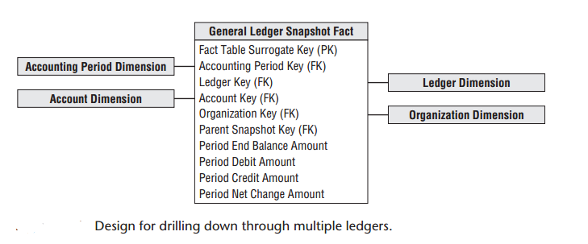

Financial Statements

Rather than looking at general ledger account level data, the fact data would be aggregated and tagged with the appropriate financial statement line number and label. In this manner, managers could easily look at performance trends for a given line in the financial statement over time for their organization

Budgeting Process

Within most organizations, the budgeting process can be viewed as a series of events. Prior to the start of a fiscal year, each cost center manager typically creates a budget, broken down by budget line items, which is then approved. In reality, budgeting is seldom simply a once-per-year event.

Managers want to see the current budget’s status, as well as how the budget has been altered since the first approved version. As the year unfolds, commitments to spend the budgeted monies are made. Finally, payments are processed. **As a dimensional modeler**, you can view the budgeting chain as a series of fact  
tables.

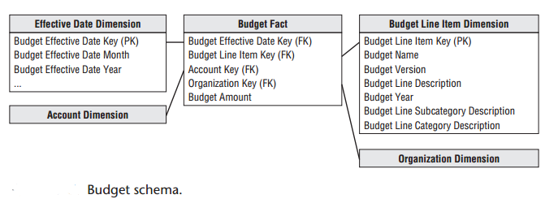

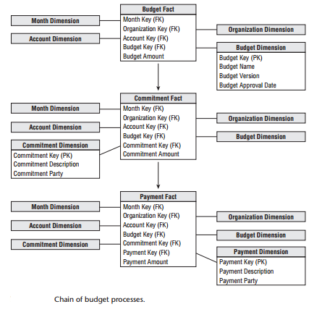

The budget line item identifies the purpose of the proposed spending, such as employee wages or office supplies. The eﬀective month is the month during which the budget changes are posted. The first entries for a given budget year would show the eﬀective month when the budget is first approved.

If the budget amount for a given budget line and account is modified during the year, an additional row  
is added to the budget fact table representing the net change

When the budget year begins, managers make commitments to **spend the budget** through purchase orders, work orders, or other forms of contracts. Managers are keenly interested in monitoring their commitments and comparing them to the annual budget to manage their spending. We can envision a second fact table for the commitments that shares the same dimensions,

Dimension Attribute Hierarchies

Fixed Depth Positional Hierarchies

A fixed position hierarchy has a fixed set of levels, all with meaningful labels. One calendar hierarchy may  
be day ➪ fiscal period ➪ year. Another could be day ➪ month ➪ year. The account dimension may also have a fixed many-to-one hierarchy such as executive level, director level, and manager level accounts. In a fixed position hierarchy, it is important that each level have a specific name.

Slightly Ragged Variable Depth Hierarchies

The simple location has four levels: address, city, state, and country. The medium complex location adds a zone level, and the complex location adds both district and zone levels. If you need to represent all three types of locations in a single geographic hierarchy, you have a slightly variable hierarchy. You can  
combine all three types if you are willing to make a compromise. The key to this compromise is the narrow range of geographic hierarchies, ranging from four levels to only six levels. If the data ranged from  
four levels to eight or ten or even more, this design compromise would not work.  
Remember the attribute names need to make sense

Ragged Variable Depth Hierarchies

The organization structure is an excellent example of a ragged hierarchy of indeterminate depth. Imagine your enterprise consists of 13 organizations. Each of these organizations has its own budget, commitments, and payments. The classic way to represent a parent/child tree structure is by placing recursive pointers in the organization dimension from each row to its parent. The solution to the problem of representing arbitrary rollup structures is to build a special kind of bridge table that is independent from the primary dimension table and contains all the information about the rollup.

Time Varying Ragged Hierarchies

The ragged hierarchy bridge table can accommodate slowly changing hierarchies with the addition of two date/time stamps. When a given node no longer is a child of another node, the end eﬀective date/time of the old relationship must be set to the date/time of the change, and new path rows inserted  
into the bridge table with the correct begin eﬀective date/time

Consolidated Fact Tables

Fact tables that combine metrics from multiple business processes at a common granularity are referred to as *consolidated fact tables*. Although consolidated fact tables can be useful, both in terms of performance and usability, they often represent a dimensionality compromise as they consolidate facts at the “least  
common denominator” of dimensionality.

Role of OLAP

OLAP products have been used extensively for financial reporting, budgeting, and consolidation applications. Relational dimensional models often feed financial OLAP cubes. OLAP cubes can deliver fast query performance that is critical for executive usage. OLAP is well suited to handle complicated organizational rollups, as well as complex calculations.

THE END